80% Vaccination Uptake

Population-wise projections

Cervical Cancer Incidence
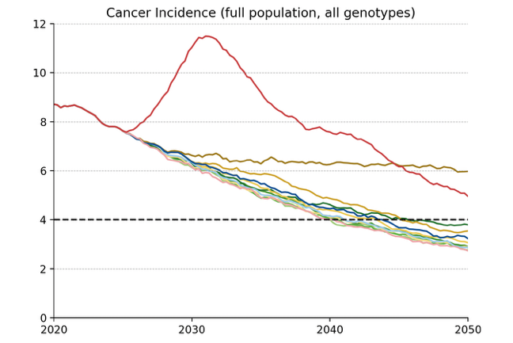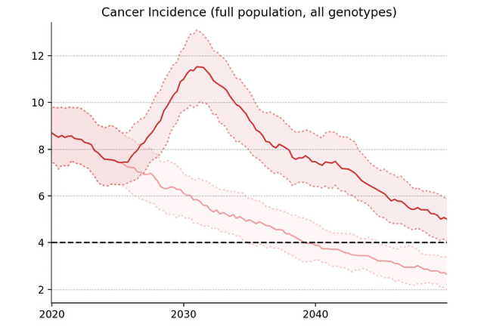
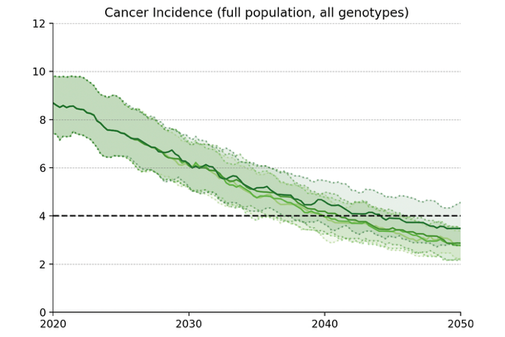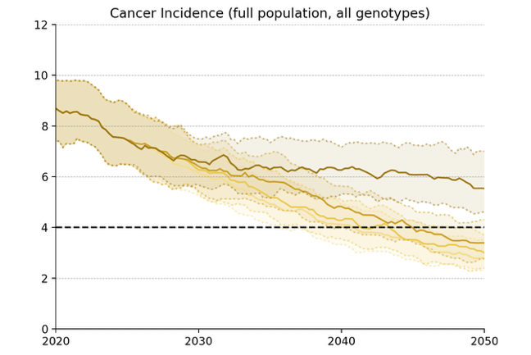
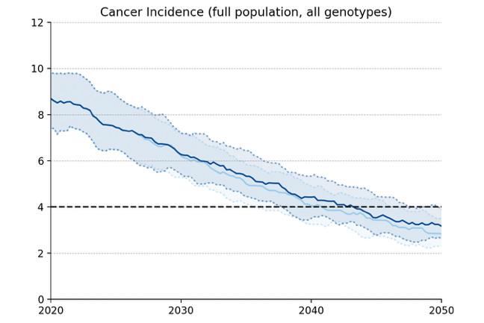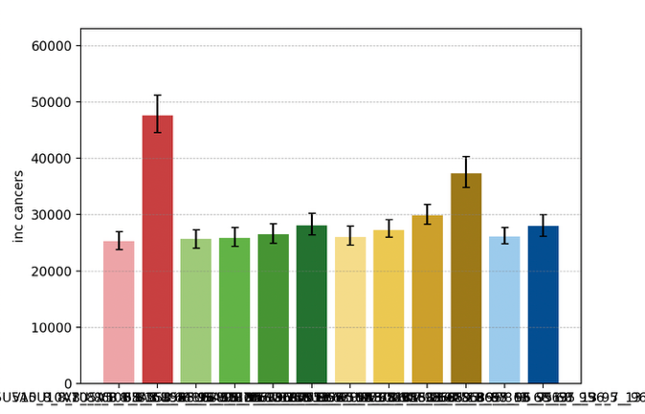
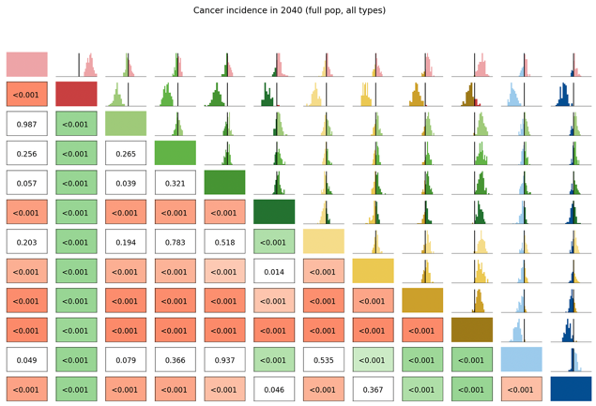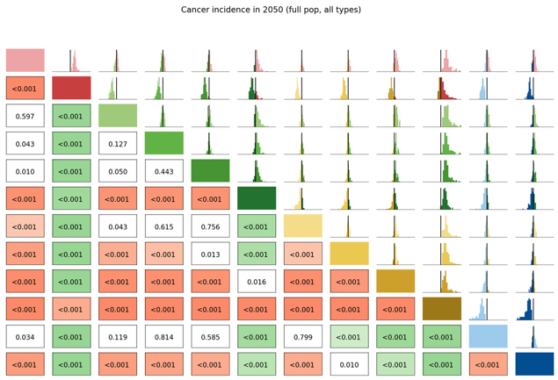

Long Term Undiagnosed Prevalence
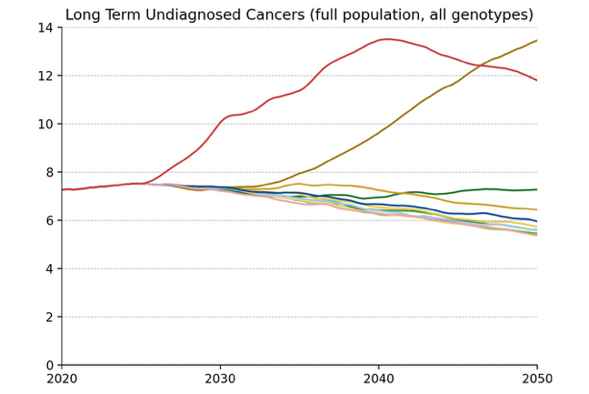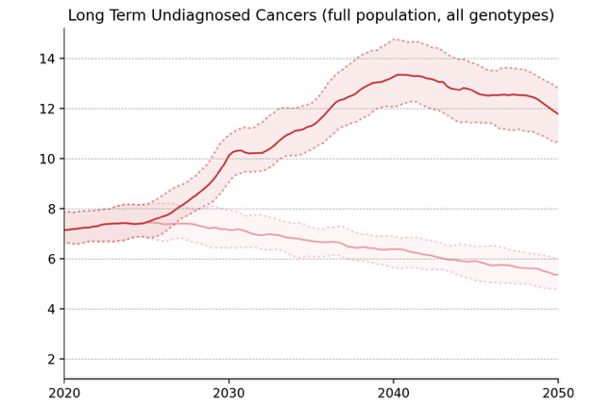
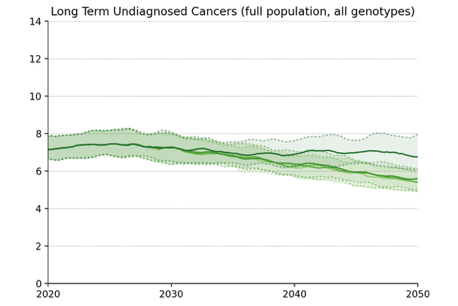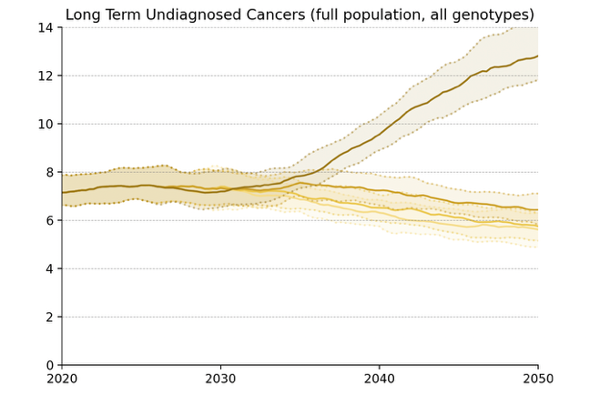
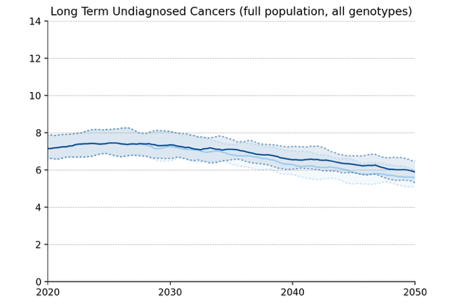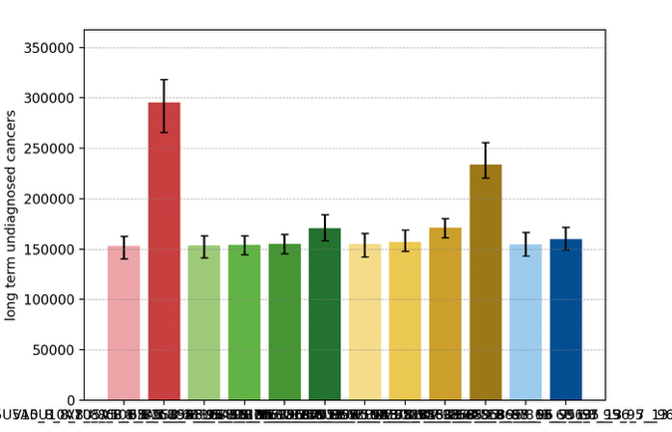
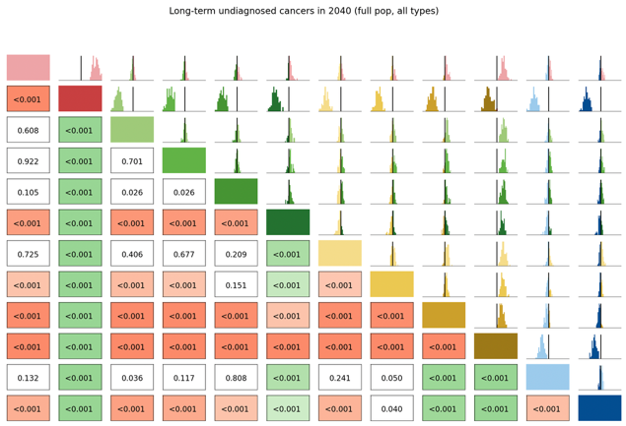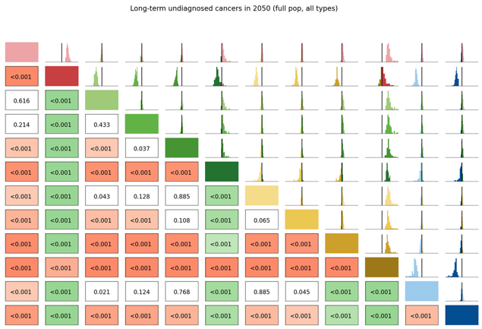

Number of Routine Screens
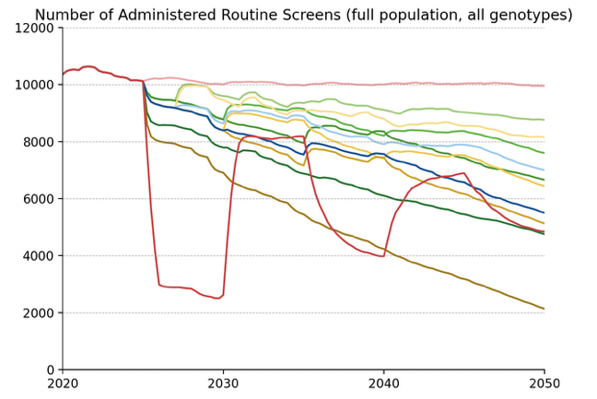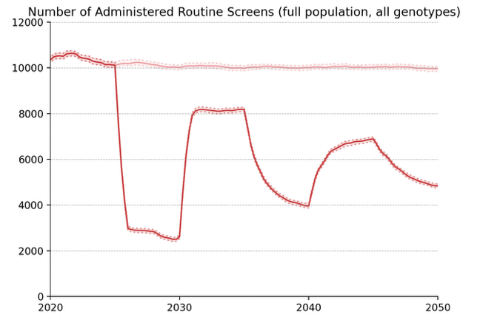
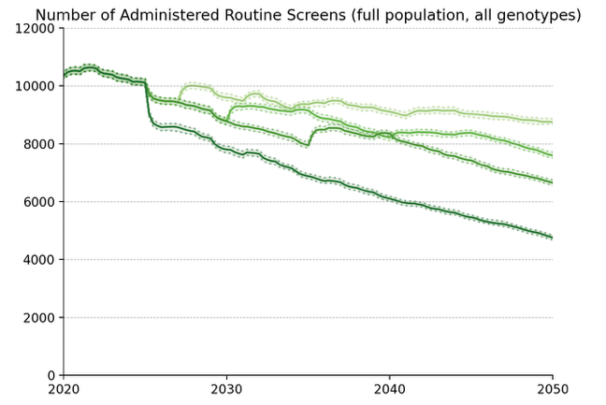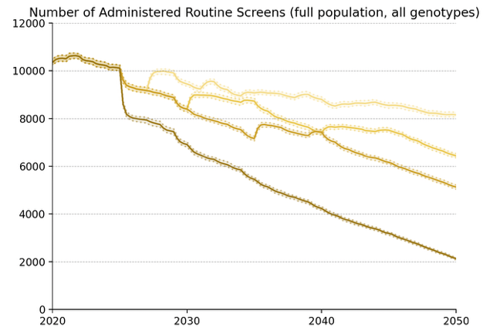
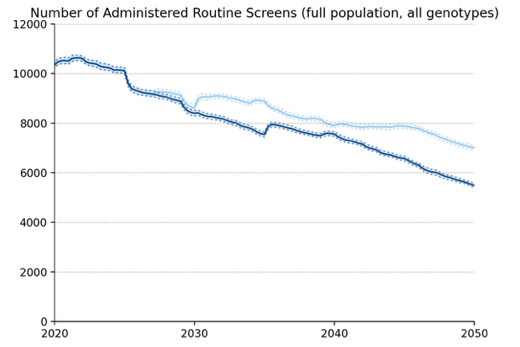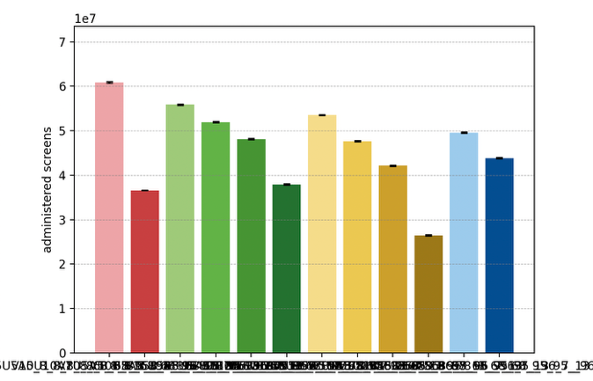

Average Number of Screens per Diagnosed Cancer, 2030-50
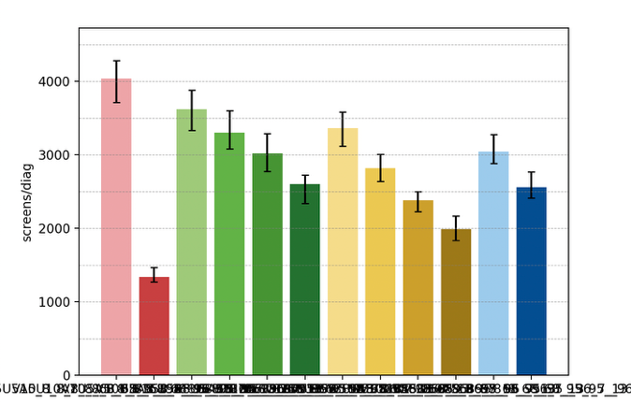

Elimination Probability Table
alg | Elimination Year: Median [LQ, UQ] (_8) | 2040.25 Elimination Probability (_8) | 2050.25 Elimination Probability (_8)
V5U5A5 | 2044 [2042, 2047] | 0.144 | 0.929
V7U5A5 | 2045 [2043, 2046] | 0.113 | 0.949
V10U5A5 | 2045 [2043, 2048] | 0.144 | 0.908
V15U5A5 | 2045 [2043, 2047] | 0.102 | 0.836
V_U5A5 | 2050 [2047, 2054] | 0.040 | 0.464
V7U7A5 | 2046 [2043, 2048] | 0.071 | 0.918
V10U10A5 | 2047 [2044, 2049] | 0.071 | 0.805
V15U15A5 | 2050 [2047, 2053] | 0.020 | 0.546
V_U_A5 | 2055 [2055, 2056] | 0.020 | 0.020
V10U7A5 | 2046 [2044, 2048] | 0.061 | 0.867
V15U10A5 | 2047 [2044, 2051] | 0.071 | 0.701
V10U10A10 | 2055 [2054, 2055] | 0.020 | 0.040
Maximum margin: 0.0993122413234564

Vaccinated Subpopulation projections

Cervical Cancer Incidence
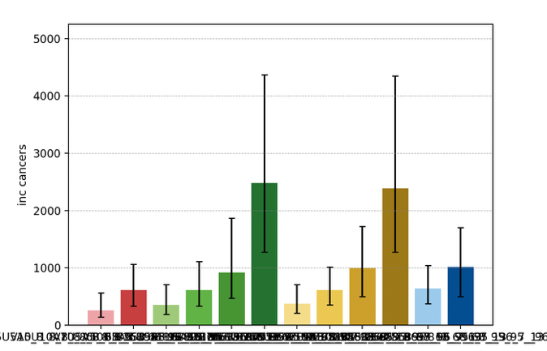
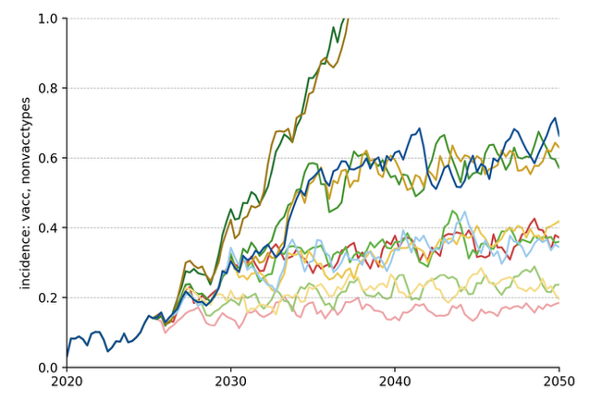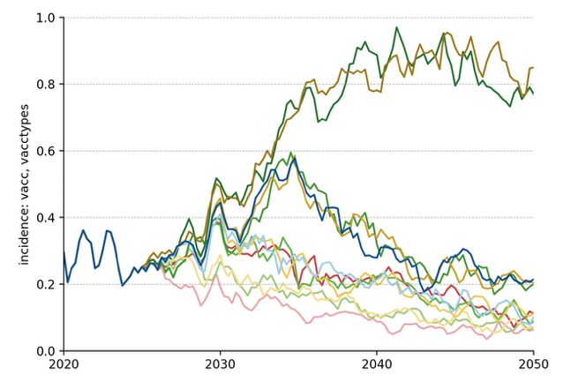
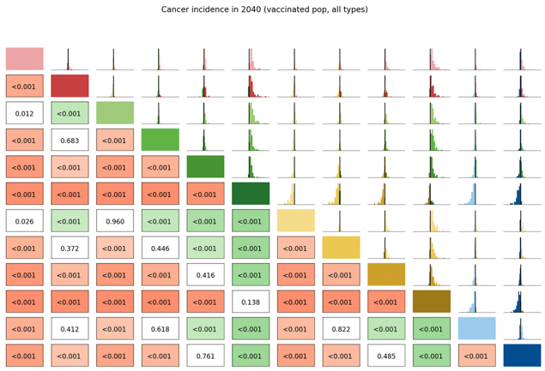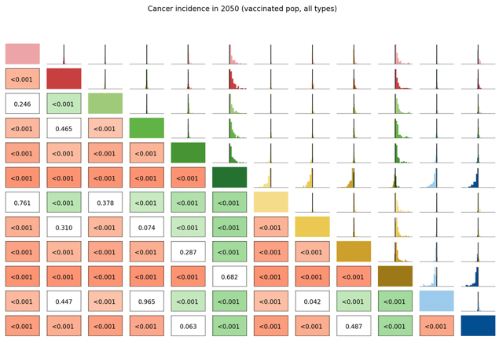

Long Term Undiagnosed Prevalence
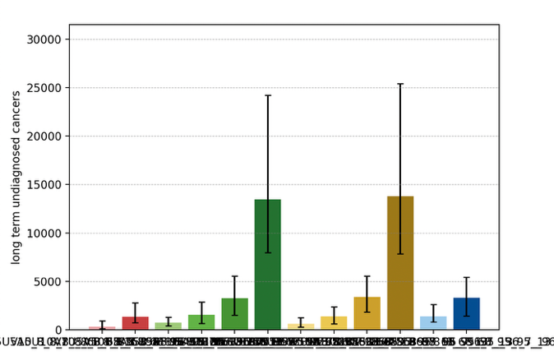
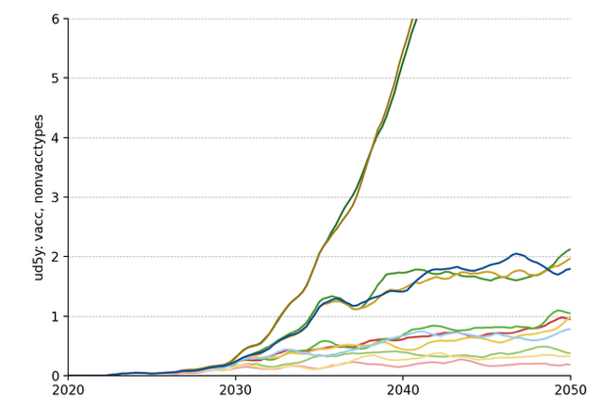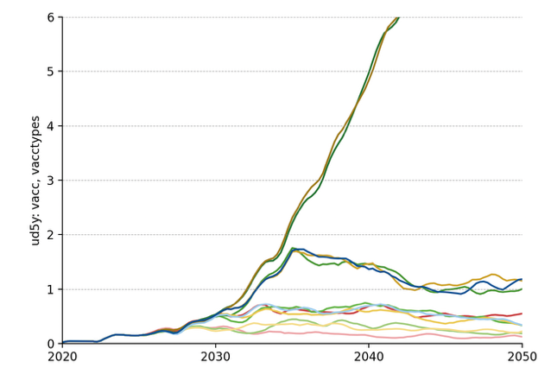
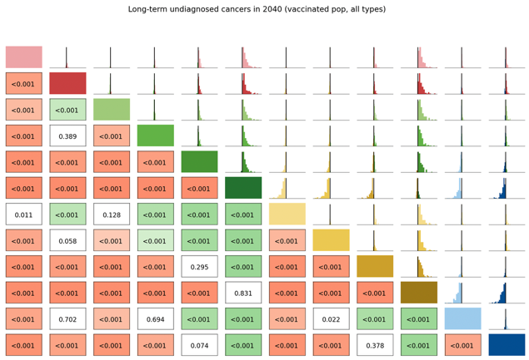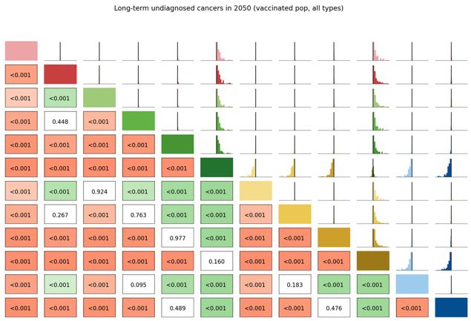

Number of Routine Screens
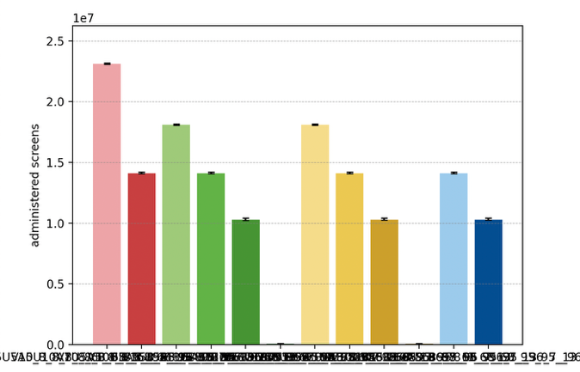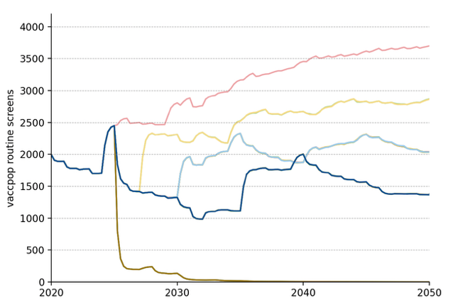

Average Number of Screens per Diagnosed Cancer, 2030-50
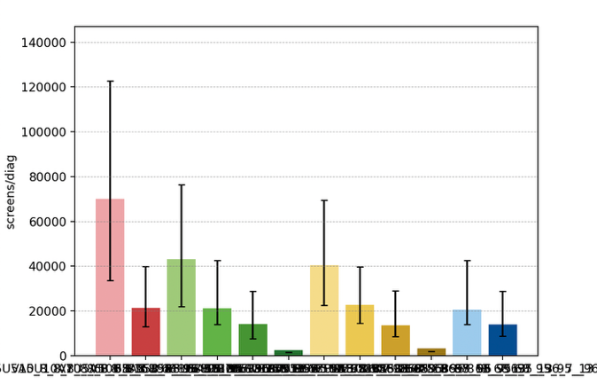

Elimination Probability Table
alg | Elimination Year: Median [LQ, UQ] (_8) | 2040.25 Elimination Probability (_8) | 2050.25 Elimination Probability (_8)
V5U5A5 | 2008 [2008, 2008] | 0.980 | 0.980
V7U5A5 | 2008 [2008, 2008] | 0.960 | 0.980
V10U5A5 | 2008 [2008, 2008] | 0.939 | 0.960
V15U5A5 | 2008 [2008, 2008] | 0.898 | 0.929
V_U5A5 | 2008 [2008, 2055] | 0.598 | 0.670
V7U7A5 | 2008 [2008, 2008] | 0.980 | 0.980
V10U10A5 | 2008 [2008, 2008] | 0.939 | 0.960
V15U15A5 | 2008 [2008, 2008] | 0.887 | 0.908
V_U_A5 | 2008 [2008, 2055] | 0.619 | 0.650
V10U7A5 | 2008 [2008, 2008] | 0.939 | 0.960
V15U10A5 | 2008 [2008, 2008] | 0.908 | 0.918
V10U10A10 | 2008 [2008, 2008] | 0.939 | 0.960
Maximum margin: 0.0975672847027755

Unvaccinated Vaccine Eligible Subpopulation projections

Cervical Cancer Incidence
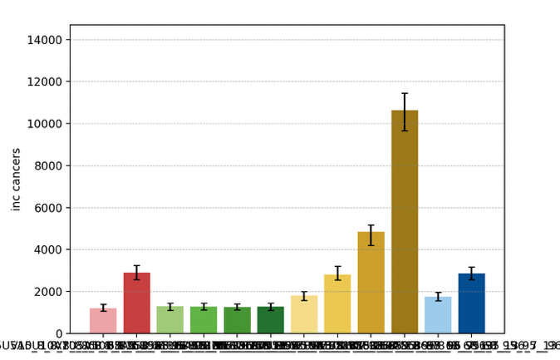
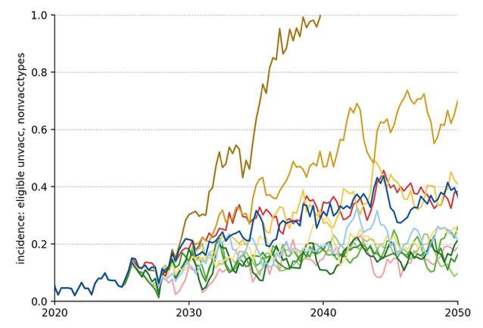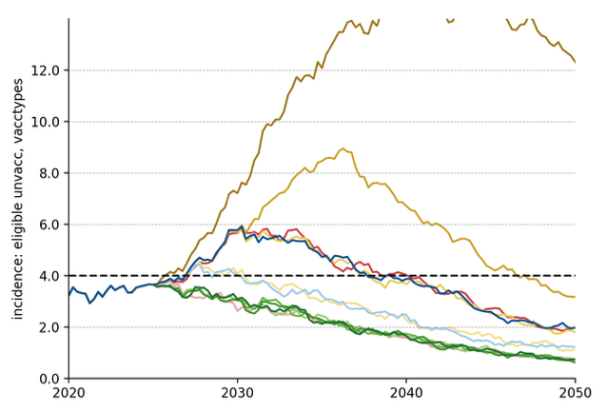
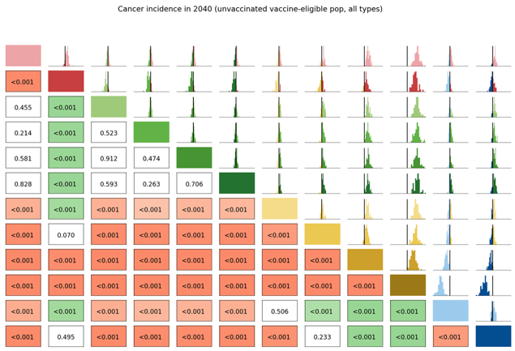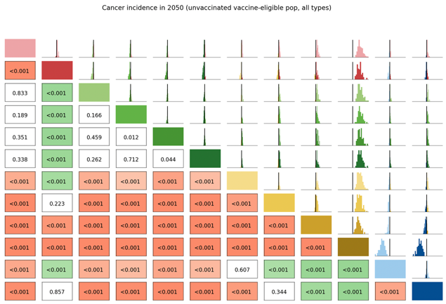

Long Term Undiagnosed Prevalence
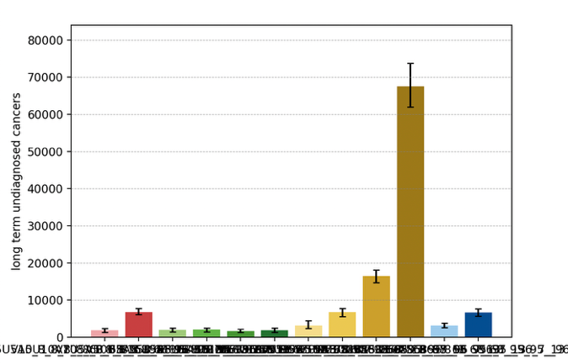
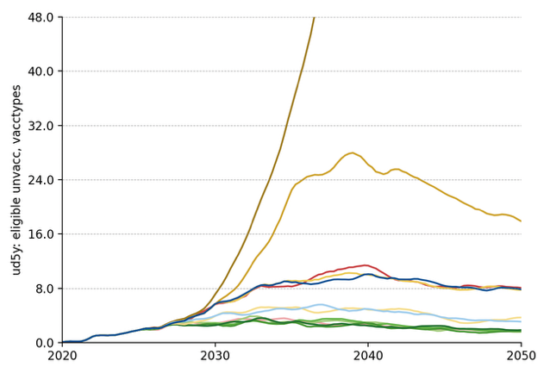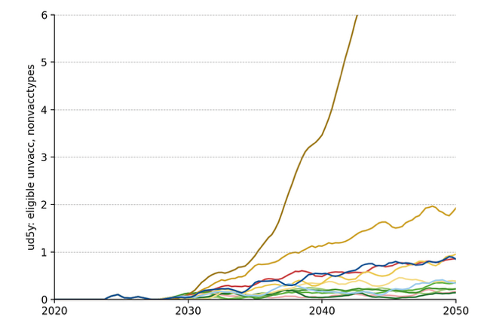
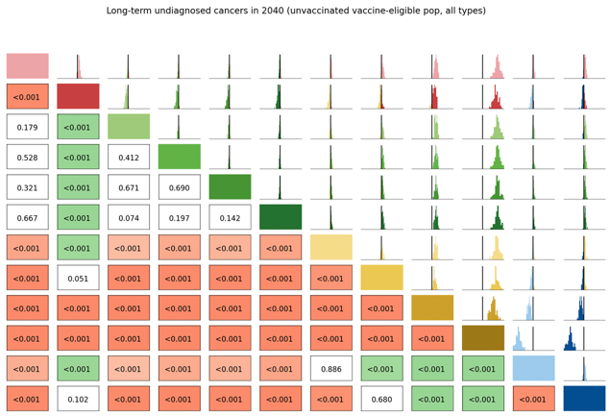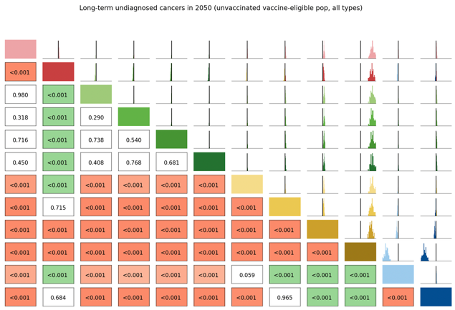

Number of Routine Screens
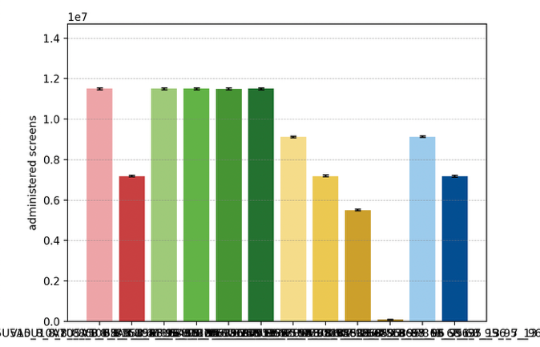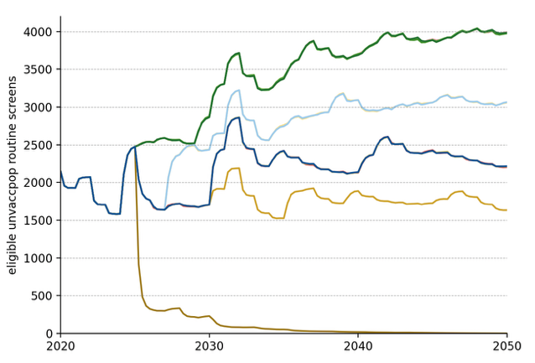

Average Number of Screens per Diagnosed Cancer, 2030-50
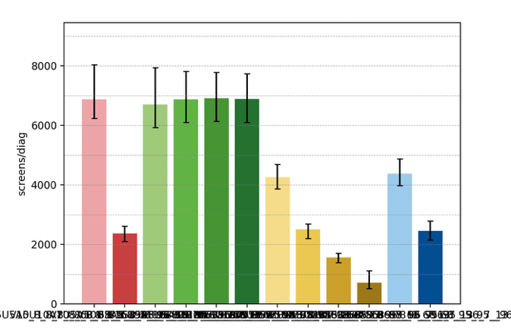

Elimination Probability Table
alg | Elimination Year: Median [LQ, UQ] (_8) | 2040.25 Elimination Probability (_8) | 2050.25 Elimination Probability (_8)
V5U5A5 | 2037 [2034, 2039] | 0.805 | 0.980
V7U5A5 | 2037 [2034, 2039] | 0.763 | 0.970
V10U5A5 | 2036 [2033, 2038] | 0.846 | 0.960
V15U5A5 | 2037 [2034, 2039] | 0.805 | 0.970
V_U5A5 | 2036 [2034, 2039] | 0.805 | 0.970
V7U7A5 | 2041 [2038, 2044] | 0.454 | 0.898
V10U10A5 | 2046 [2044, 2051] | 0.020 | 0.732
V15U15A5 | 2054 [2052, 2055] | 0.020 | 0.133
V_U_A5 | 2056 [2056, 2056] | 0.020 | 0.020
V10U7A5 | 2040 [2038, 2043] | 0.536 | 0.918
V15U10A5 | 2048 [2044, 2051] | 0.030 | 0.629
V10U10A10 | 2048 [2046, 2051] | 0.040 | 0.670
Maximum margin: 0.09931224132345641

